Two club soccer teams, the Wildcats and the Mud Cats, are hoping to obtain new equipment for an upcoming season. Table 7.6.1 shows the needs of both teams.



A goal costs $300; a ball costs $10; and a jersey costs $30. How can we find the total cost for the equipment needed for each team? In this section, we discover a method in which the data in the soccer equipment table can be displayed and used for calculating other information. Then, we will be able to calculate the cost of the equipment.

Solution:-

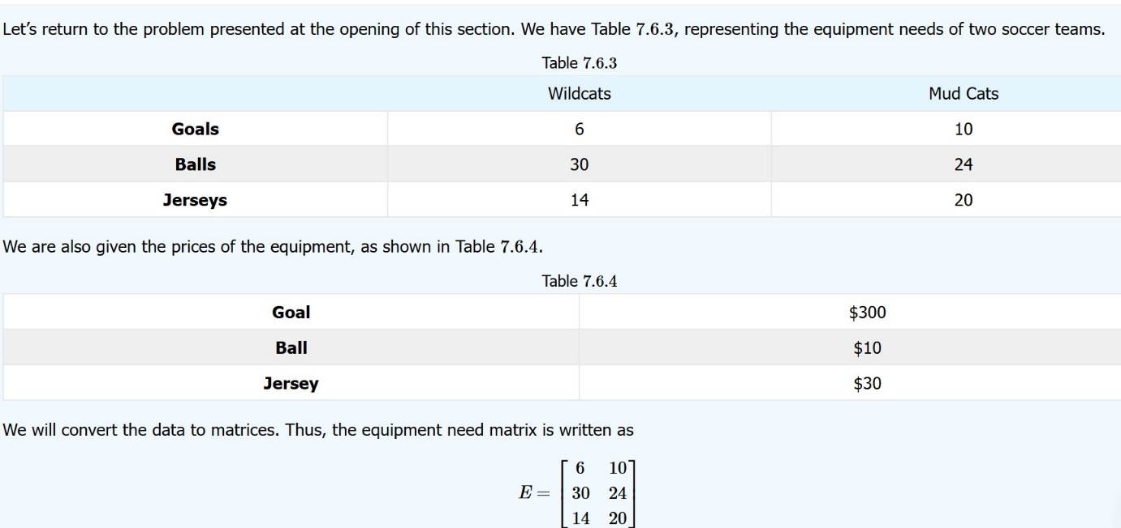

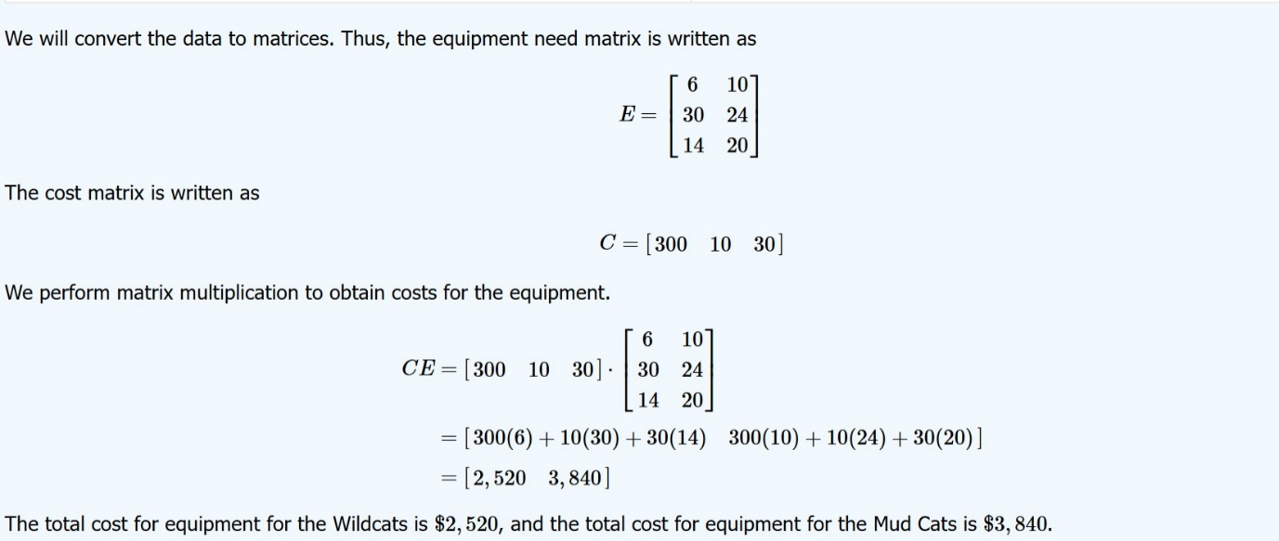

Q 2] 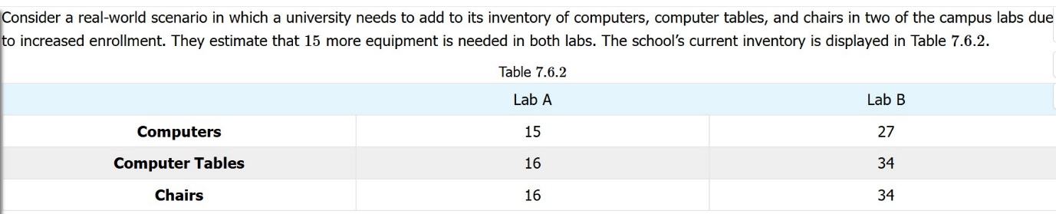

Solution:-

